1. **Accounts:**

Get: http://localhost:8080/rest/accounts

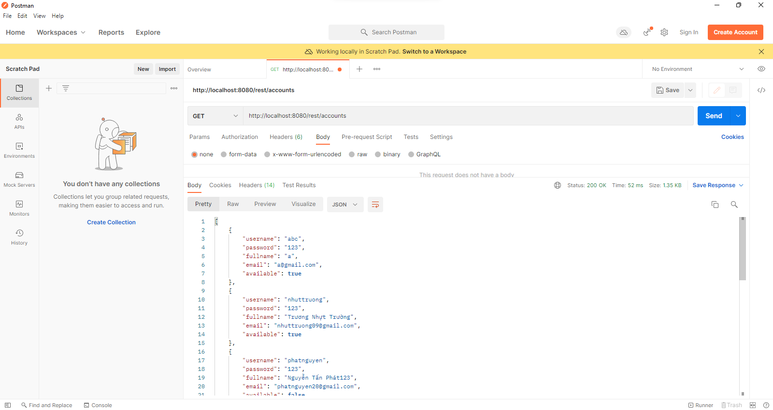

POST: <http://localhost:8080/rest/accounts>

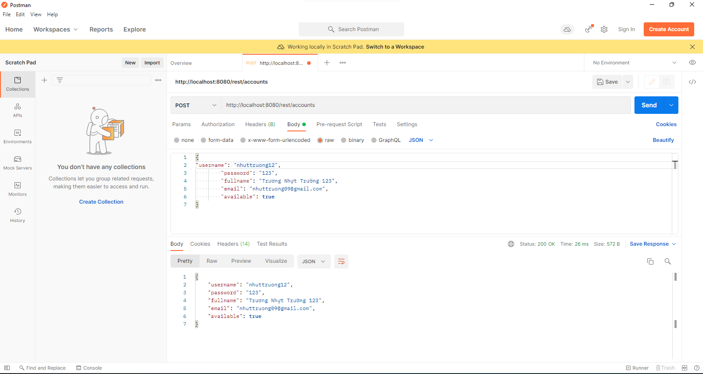

PUT: http://localhost:8080/rest/accounts/hello

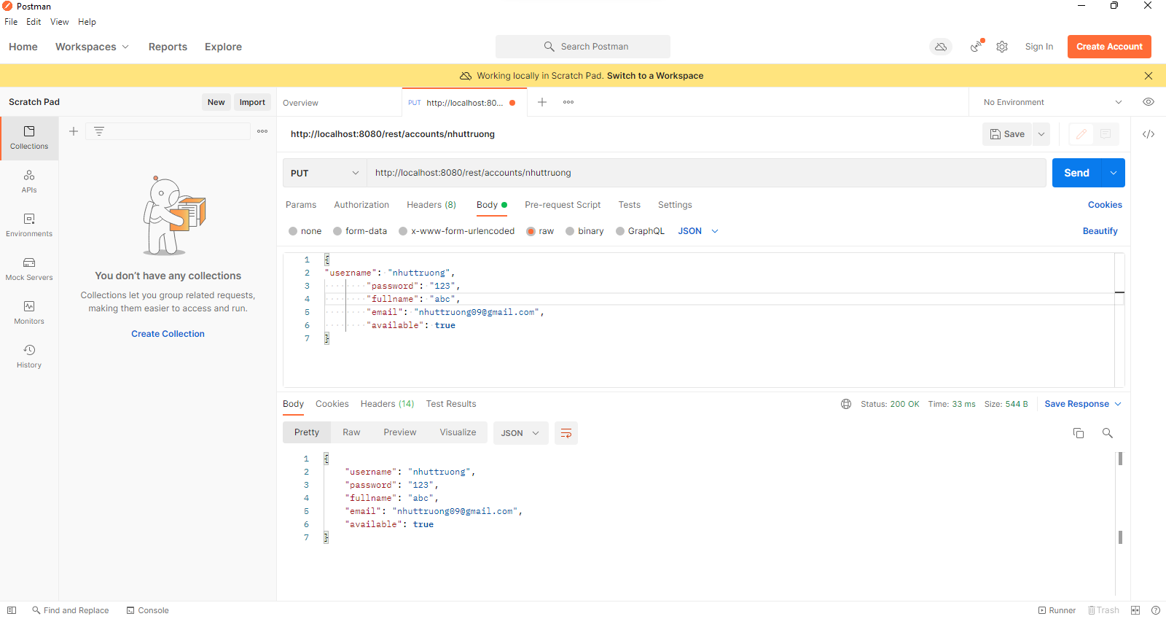

DELETE: http://localhost:8080/rest/accounts/hello

